

**HUMAN BIOLOGY**

**Unit 1**

**2018**

Name: _______________________________________________________

Teacher: ___________________________________________________

**Time allowed for this paper**

Reading time before commencing work: ten minutes

Working time: two hours thirty minutes

**Materials required/recommended for this paper**

***To be provided by the supervisor***

Question/Answer Booklet One: Contains Sections One and three.

Multiple-choice answer sheet for Section One

Question/Answer Booklet Two: Contains Section Two

***To be provided by the candidate***

* Standard items: pens (blue/black preferred), pencils (including coloured), sharpener,

correction fluid/tape, eraser, ruler, highlighters

* Special items: non-programmable calculators approved for use in this examination

**Important note to candidates**

No other items may be taken into the examination room. It is **your** responsibility to ensure that you do not have any unauthorised material. If you have any unauthorised material with you, hand it to the supervisor **before** reading any further.

**BOOKLET 2: SECTION 2**

**Structure of this paper**

|  |  |  |  |  |  |
| --- | --- | --- | --- | --- | --- |
| Section | Number of questions available | Number of questions to be answered | Suggested working time (minutes) | Marks  available | Percentage of examination |
| Section One  Multiple-choice | 25 | All | 30 | 25 | 30 |
| Section Two  Short answer | 9 | All | 80 | 85 | 50 |
| Section Three  Extended answer | 3 | 2 | 40 | 30 | 20 |
| **Total** | | | | | 100 |

**Instructions to candidates**

1. The rules for the conduct of the Western Australian external examinations are detailed in the *Year 12 Information Handbook 2018.* Sitting this examination implies that you agree to abide by these rules.

2. Answer the questions according to the following instructions.

**Section One:** Answer all questions on the separate **Multiple-choice Answer Sheet** provided. For each question, shade the box to indicate your answer. Use only a blue or black pen to shade the boxes. If you make a mistake, place a cross through that square, then shade your new answer. Do not erase or use correction fluid/tape. Marks will not be deducted for incorrect answers. No marks will be given if more than one answer is completed for any question.

**Sections Two:** Write your answers in **Question/Answer Booklet Two**. Wherever possible, confine your answers to the line spaces provided.

**Section Three:** Consists of three questions. You must answer **two questions**. Tick the box next to the question you are answering. Write your answers in **Question/Answer Booklet One**.

3. You must be careful to confine your responses to the specific questions asked and to follow any instructions that are specific to a particular question.

4. Supplementary pages for the use of planning or continuing an answer to a question have been provided at the end of both Question/Answer booklets. If you use these pages to continue an answer, indicate at the original answer where the answer is continued, i.e. give the page number. Write all answers for **Section 2 in Booklet Two.** Write all answers for **Section 3 in Booklet One.**

**Section Two: Short answer 50% (85 Marks)**

This section has **nine (9)** questions. Answer **all** questions. Write your answers in the spaces provided.

Supplementary pages for the use of planning/continuing your answer to a question have been provided at the end of this Question/Answer booklet. If you use these pages to continue an answer, indicate the original answer where the answer is continued, i.e. give the page number.

Suggested working time: 80 minutes.

**Question 26 (5 marks)**

The following question refers to the diagram of the plasma membrane shown below.

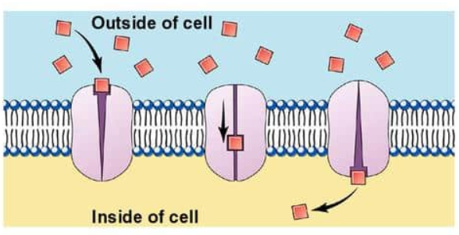

**Figure 1 Plasma membrane**

1. Identify the type of membrane transport shown in the diagram above. (1 mark)

________________________________________________________________________

1. Name **one** substance that is transported using the type of membrane transport identified in part (a). (1 mark)

______________________________________________________________________

1. State a location in the human body that this mode of membrane transport is most likely to take place. (1 mark)

_________________________________________________________________________

1. State **two** characteristics of carrier-mediated transport in the cell membrane. (2 marks)

__________________________________________________________________________________________________________________________________________________

**Question 27 (12 marks)**

1. Using a fully annotated diagram in the space below, demonstrate the lock and key model for an enzyme reaction.

(4 marks)

1. Why is an enzyme described as being “substrate-specific”? (1 mark)

__________________________________________________________________________________________________________________________________________________

1. How does an enzyme act as a catalyst for reactions? (1 mark)

_________________________________________________________________________

_________________________________________________________________________

Enzymes are necessary for chemical reactions to occur at a rate that can support biological life. The following graph shows the initial rate of reaction of the enzyme fluoroacetate dehalogenase (FAcD) as it converts substrates into products, glycolate and a halogen; as substrate concentration is increased over a period of an hour.

**Initial rate of reaction with increasing substrate concentration**

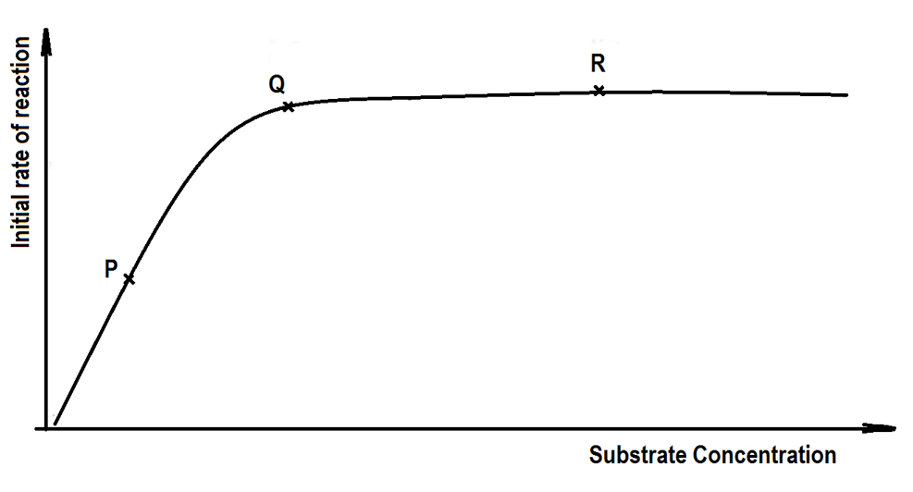

**Figure 3**

1. Using the terms `**active site’**, **`rate of reaction’**, `**substrate’** and `**enzyme’** molecules, explain what has happened at point P, Q and R. (6 marks)
2. P

___________________________________________________________________

___________________________________________________________________

(ii) Q

___________________________________________________________________

__________________________________________________________________

1. R

___________________________________________________________________

___________________________________________________________________

**Question 28 (10 marks)**

1. Draw an annotated diagram of the sliding filament model and explain how muscle contraction takes place using this model. (5 marks)

________________________________________________________________________

________________________________________________________________________

________________________________________________________________________

________________________________________________________________________

________________________________________________________________________

1. Name and describe a muscular **or** a skeletal condition that occurs due to ageing. (2 marks)

_________________________________________________________________________

_________________________________________________________________________

_________________________________________________________________________

1. State **one** common treatment used to prevent the onset of this named condition in part (c).

(1 mark)

_________________________________________________________________________

Please read the following paragraph carefully to answer question (e).

**Use of Personal Devices in Diagnosis and Treatment**

The rise of increasingly sophisticated personal devices such as the iPhones and Fitbits means scientists can access information across all aspects of our daily lives. This information provided to scientists will give us a better insight than ever before into how and when we get sick. At the forefront of this research is the Centre for Big Data Research in Health (CBDRH), at Australia’s University of New South Wales. This research centre is using an array of personal devices to find new ways of diagnosing and treating health diseases. “Smartphones now come with very sensitive accelerometers that can pick up the slightest tap or jiggle, so they are good devices to measure any type of body movement,” says Dr Timothy Churches, a data scientist at CBDRH and the Ingham Institute in Sydney. Australian scientists are currently looking at using smartphones to characterise the gaits of patients after surgery, and using machine learning methods to try and detect changes that could occur in patients suffering from musculo-skeletal dysfunctions.

Adapted from Cosmos Magazine 9 Oct 2017

1. Comment on how the use of smartphones can be used to improve practices for the management and prevention of the condition identified in parts (c) and (d). (2 marks)

__________________________________________________________________________________________________________________________________________________

_________________________________________________________________________

_________________________________________________________________________

**Question 29 (5 marks)**

1. Name the location in the cell where each of these processes below occur. (3 marks)

|  |  |
| --- | --- |
| **Process** | **Location in the cell** |
| Glycolysis |  |
| Krebs Cycle  (citric acid cycle) |  |
| Electron transport chain |  |

1. Explain why the mitochondria are described as the `power house’ of the cell.

(2 marks)

_____________________________________________________________________

_____________________________________________________________________

**Question 30 (8 marks)**

The following questions refer to the diagram of the human digestive system shown below.

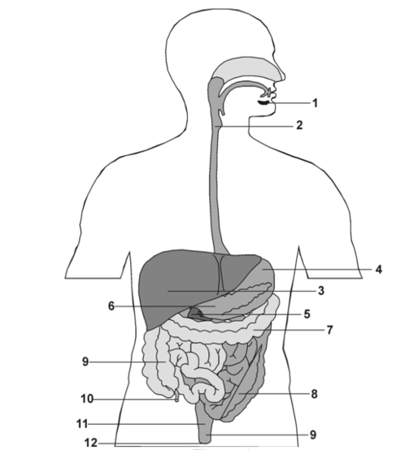

**Figure 4 Human Digestive System**

1. A slide has been taken from the longitudinal section of the tissue located in position **2,** showing the mucosa and muscle layers of this tissue.

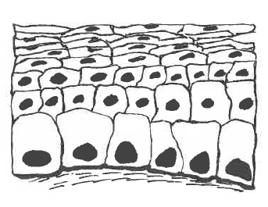

**Figure 5 Longitudinal section of tissue**

1. Identify the type of cell in Figure 5 and state a function of these cells. (2 marks)

___________________________________________________________________

___________________________________________________________________

The diagram below show the muscle layers that are located also at location 2

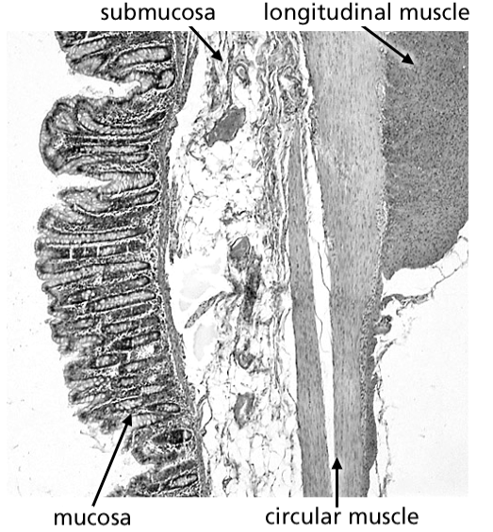

**Figure 6 Muscular tissue**

(ii) As shown above, the muscle is arranged into both circular and longitudinal directions. State why this muscle arrangement is necessary at location 2**.** (1 mark)

___________________________________________________________________

___________________________________________________________________

(iii) State **two** other locations from Figure 4: Human Digestive System that would share the same function as this muscle arrangement. (1 mark)

___________________________________________________________________

1. State **two** structural similarities and **one** difference between locations 2 and 8. (3 marks)

_________________________________________________________________________

__________________________________________________________________________________________________________________________________________________

1. Unlike the rest of the human digestive system, the stomach has an oblique muscle layer in addition. State how this facilitates its function. (1 mark)

_________________________________________________________________________

_________________________________________________________________________

**Question 31 (9 marks)**

The heart is a muscular organ that lies in the thoracic cavity behind the sternum. It has four chambers and these are connected to large blood vessels that carry blood towards and away from the heart.

1. Name the blood vessel associated with the heart that matches the appropriate description in the table below.

(4 marks)

|  |  |
| --- | --- |
| **Description** | **Blood vessel** |
| It supplies the heart muscle with oxygenated blood |  |
| It has the highest blood pressure |  |
| It carries oxygenated blood to the heart |  |
| It joins the ventricles of the heart to the capillaries of the lungs |  |

1. Explain why it is important to prevent mixing of the blood in the two sides of the heart.

(2 marks)

_________________________________________________________________________

__________________________________________________________________________________________________________________________________________________

Question 31(c) refers to the graph below which shows the rate of blood flow from and to the heart through a variety of blood vessels.

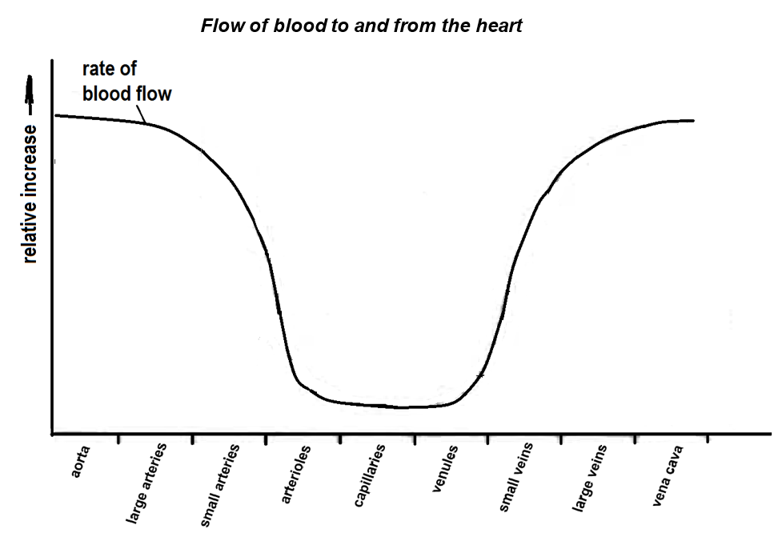

**Figure 7**

1. Describe **three** changes in the rate of blood flow as blood passes from the aorta to the vena cava. (3 marks)

____________________________________________________________________

____________________________________________________________________

____________________________________________________________________

**Question 32 (16 marks)**

There are a number of factors that separately increase the risk of an individual suffering from cardiovascular disease. When combined together, the overall risk can be greatly amplified. An investigation was conducted to show the effect of three risk factors; namely, smoking, high blood pressure and blood cholesterol on the chance of heart attack in Australian men.

Category A refers to men who are heavy smokers and have high blood pressure.

Category B refers to men who are non-smokers and have high blood pressure.

Category C refers to men who are heavy smokers and have low blood pressure.

Category D refers to men who are non-smokers and have low blood pressure.

Data was collected from these four categories of men from a sample size of 1200 men. The percentage of these men suffering from a heart attack in a 5-year-period had a range of blood cholesterol levels varying from 5 mmol/L to 8 mmol/L. This information was recorded by a team of medical researchers at the University of Western Australia and the Royal Perth Hospital.

|  |  |  |  |  |
| --- | --- | --- | --- | --- |
| Blood cholesterol level  (mmol/L) | Percentage of men suffering from heart attack (%) | | | |
| Category A | Category B | Category C | Category D |
| 5.0 | 9 | 5 | 4 | 3 |
| 6.0 | 12 | 8 | 6 | 4 |
| 7.0 | 18 | 14 | 9 | 7 |
| 8.0 | 28 | 20 | 15 | 11 |

1. List **two** variables that should be controlled in the experiment. (2 marks)

__________________________________________________________________

__________________________________________________________________

1. Graph the results from the table on the grid provided. (6 marks)

A spare grid is provided at the end of this Question/Answer booklet. If you need to use

it, cross out this attempt.

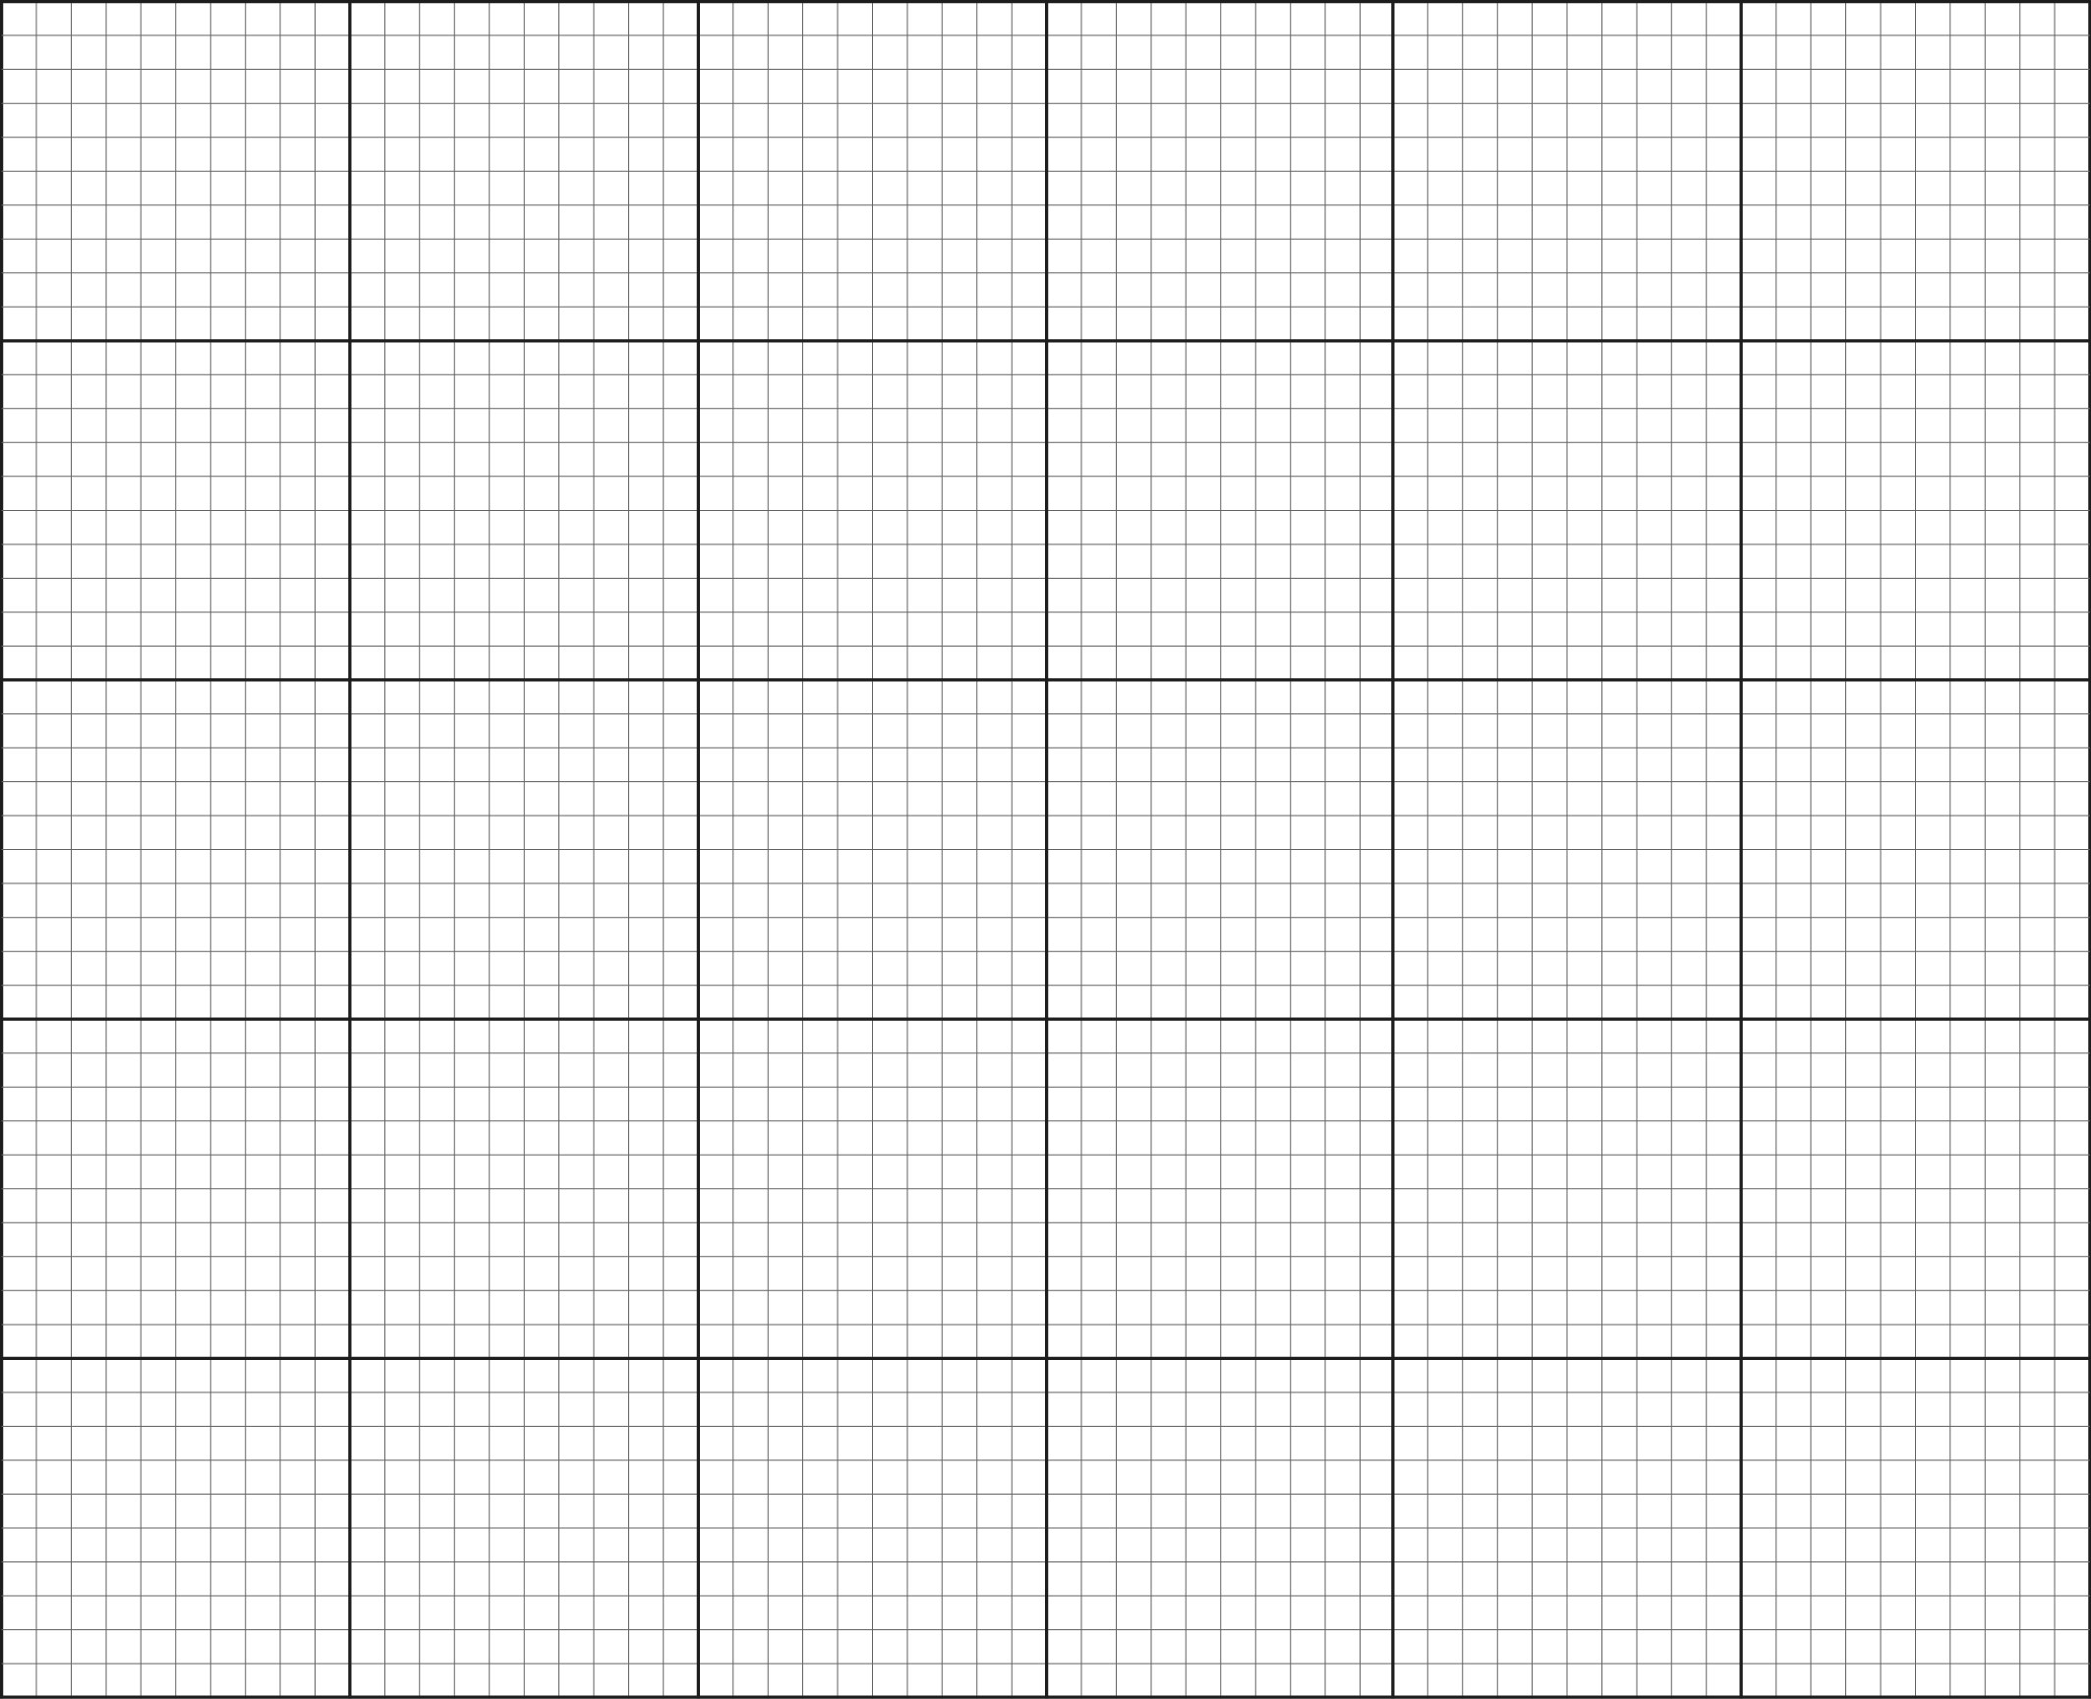

1. A smoker who has high blood pressure would like to reduce his risk of heart attack. If he could only change one risk factor, would he be better to give up smoking or to try reducing his blood pressure? With reference to your plotted graph, give a reason for your answer.

(2 marks)

_________________________________________________________________________

_________________________________________________________________________

1. A non-smoker with high blood pressure has a blood cholesterol of 5 mmol/L. Over a period of three years, his blood pressure increases to 8 mmol/L. According to the graph, calculate how many times greater his risk of heart disease is. Show your working.

(2 marks)

__________________________________________________________________________________________________________________________________________________

1. Two non-smoking men with low blood pressure both have a blood cholesterol level of 5 mmol/L. One of the men starts smoking and the other man’s blood cholesterol level increases to 7 mmol/L. Which one of the two men is now at greater risk of suffering a heart attack? Explain your answer referring to data in the graph. (2 marks)

_________________________________________________________________________

_________________________________________________________________________

1. Identify **two** components of a person’s diet that may contribute to an increase in the risk of heart disease.

(2 marks)

_________________________________________________________________________

_________________________________________________________________________

**Question 33 (10 marks)**

The following questions refer to the diagram below showing a kidney nephron.

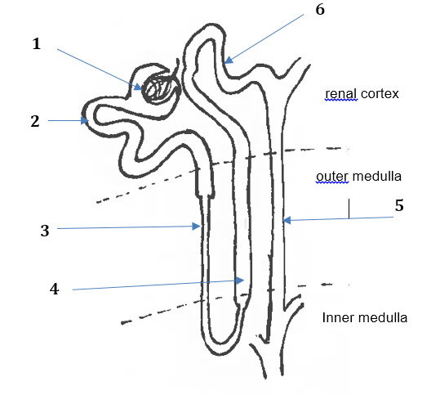

**Figure 8 Kidney nephron**

1. Match each of the processes (identified on the diagram with numbers 1 – 7) to the correct description of the process. Write the process number next to the correct description in the first column. Identify **one** substance passing through during this process in the last column where substances passing through are **not** given.

(8 marks)

|  |  |  |
| --- | --- | --- |
| **Process number** | **Description of the process** | **Substances passing through** |
|  | Filtration through the membranes of a glomerulus. |  |
|  | Reabsorption by osmosis in the descending limb of the loop of Henle. | water |
|  | Active transport of salt from the ascending limb of the loop of Henle. |  |
|  | Active secretion of ions in the distal convoluted tubule |  |
|  | Concentration of urine by osmotic withdrawal from the filtrate in the collecting duct | water |

1. Describe **one** feature of the proximal convoluted tubule that facilitates its function.

(2 marks)

_________________________________________________________________________

_________________________________________________________________________

_________________________________________________________________________

_________________________________________________________________________

**Question 34 (10 marks)**

1. To allow movement, the skeletal system consists of many bones held together at joints by flexible connective tissues and ligaments. Identify and describe the **three** classes of joint types. (6 marks)

________________________________________________________________________

________________________________________________________________________

________________________________________________________________________

________________________________________________________________________

________________________________________________________________________

________________________________________________________________________

1. Explain how antagonistic muscles work differently from synergistic muscles. (2 marks)

________________________________________________________________________

________________________________________________________________________

________________________________________________________________________

1. Bone is classified as a connective tissue. Connective tissues consist of cells separated from each other by large amounts of matrix. Complete the table below to show the structural difference between bone and cartilage on a cellular level. (2 marks)

|  |  |  |
| --- | --- | --- |
|  | ***Name of the microscopic structure*** | ***Description*** |
| Microscopic structure of compact bone |  | At the centre of each unit, is a central canal around which are concentric layer of bone matrix. |
| Microscopic structure of  cartilage |  | Collagen fibres are embedded in the matrix and within the matrix are spaces that contain cartilage cells. |

**End of Section Two**

Question number: ________________

_____________________________________________________________________________________________________________________________________________________________________________________________________________________________________________________________________________________________________________________________________________________________________________________________________________________________________________________________________________________________________________________________________________________________________________________________________________________________________________________________________________________________________________________________________________________________________________________________________________________________________________________________________________________________________________________________________________________________________________________________________________________________________________________________________________________________________________________________________________________________________________________________________________________________________________________________________________________________________________________________________________________________________________________________________________________________________________________________________________________________________________________________________________________________________________________________________________________________________________________________________________________________________________________________________________________________________________________________________________________________________________________________________________________________________________________________________________________________________________________________________________________________________________________________________________________________________________________________________________________________________________________________________________________________________________________________________________________________________________________________________________________________________________________________________________________________________________________________________________________________________________________________________________________________________________________________________________________________________________________________________________________________________________________________________________________________________________________________________________________________________________________________________________

Question number: ________________

_____________________________________________________________________________________________________________________________________________________________________________________________________________________________________________________________________________________________________________________________________________________________________________________________________________________________________________________________________________________________________________________________________________________________________________________________________________________________________________________________________________________________________________________________________________________________________________________________________________________________________________________________________________________________________________________________________________________________________________________________________________________________________________________________________________________________________________________________________________________________________________________________________________________________________________________________________________________________________________________________________________________________________________________________________________________________________________________________________________________________________________________________________________________________________________________________________________________________________________________________________________________________________________________________________________________________________________________________________________________________________________________________________________________________________________________________________________________________________________________________________________________________________________________________________________________________________________________________________________________________________________________________________________________________________________________________________________________________________________________________________________________________________________________________________________________________________________________________________________________________________________________________________________________________________________________________________________________________________________________________________________________________________________________________________________________________________________________________________________________________________________________________________________

Question number: ________________

_____________________________________________________________________________________________________________________________________________________________________________________________________________________________________________________________________________________________________________________________________________________________________________________________________________________________________________________________________________________________________________________________________________________________________________________________________________________________________________________________________________________________________________________________________________________________________________________________________________________________________________________________________________________________________________________________________________________________________________________________________________________________________________________________________________________________________________________________________________________________________________________________________________________________________________________________________________________________________________________________________________________________________________________________________________________________________________________________________________________________________________________________________________________________________________________________________________________________________________________________________________________________________________________________________________________________________________________________________________________________________________________________________________________________________________________________________________________________________________________________________________________________________________________________________________________________________________________________________________________________________________________________________________________________________________________________________________________________________________________________________________________________________________________________________________________________________________________________________________________________________________________________________________________________________________________________________________________________________________________________________________________________________________________________________________________________________________________________________________________________________________________________________________

Spare Graph Paper for Question 32



**Reference List**

**Section One: Multiple Choice**

Question 2

Drawing of a leucocyte – Courtesy of S. Yap

Question 20

Drawing of a joint – Courtesy of S. Yap

**Section Two: Short Answer**

Question 26 (a)

Image Source: schoolworkhelper.net

Question 30 (a)

Figure 4 – Digestive System WATP

Figure 5 – Mucosa layer of cells – Courtesy of S. Yap

Figure 6 – Muscle layers in the tissue – <http://spice.wa.edu.au>

Question 33 (a)

Figure 8 – Picture of Kidney Nephron – Courtesy of S. Yap

WATP acknowledges the permission of the School Curriculum and Assessment Authority in providing instructions to students.